Project Directors’ Update Tool

Project Summary
Field | Response
Project name
Project Director
Reporting period
Reporting week / cycle
Project location(s)
Current project phase / activity stage | Select one primary current stage:  ○ Concept / Design ○ Start-up ○ Planning ○ Procurement / Logistics  ○ Field Implementation ○ Service Delivery  ○ Data Collection ○ Technical Assistance ○ Coordination  ○ Analysis ○ Reporting ○ Quality Assurance  ○ Corrective Action ○ Close-out  ○ Other: ____  If several workstreams are active, select the stage receiving the largest share of effort this period and note secondary workstreams in Section 8.
Overall project progress | ___ %  Standard formula: Overall progress (%) = Σ [approved activity weight (%) × verified activity completion (%)] ÷ 100.  Only approved scope changes may re-baseline the weights; reported completion must be supported by evidence.
Overall status / risk flag | ☐ Green ☐ Yellow ☐ Orange ☐ Red

Milestone Progress
Field | Response | Explain the % (How was this % calculated)
Total milestones planned | ___ | All approved project milestones in the current baseline.
Milestones completed | ___ | Milestones completed with the required evidence accepted.
Milestones remaining | ___ | Total approved milestones minus milestones completed.
Milestones delayed | ___ | Milestones past their approved due date and not yet completed.
Milestone completion rate | ___ % | Completed approved milestones ÷ total approved milestones × 100. Each milestone has equal weight for this count-based indicator only; the rate does not calculate or override overall project progress.

Implementation Progress Breakdown
Progress category | Percentage | Explain the % (How was this % calculated)
Completed | ___ % | Sum of approved weights for activities verified as 100% complete.
In progress | ___ % | Sum of approved weights for activities started (>0%) but not complete (<100%).
Not started | ___ % | Sum of approved weights for activities at 0% completion.
*Calculation rule: Use the same approved activity weights as the overall progress calculation. Completed + In progress + Not started must equal 100%. This breakdown classifies activity weights by status; it is not the overall progress percentage.

Progress Over Time
Reporting period / week | Overall progress %
Week 1 | ___ %
Week 2 | ___ %
Week 3 | ___ %
Current week | ___ %

Challenges and Support Needs
Field | Response
Number of active challenges | ___
Main challenge identified
Challenge category | ☐ Operations ☐ Finance ☐ ICT ☐ Data ☐ M&E ☐ Field ☐ Security ☐ Management ☐ Other
Effect on project | ☐ Timeline ☐ Deliverable ☐ Quality ☐ Budget ☐ Access ☐ Team performance
Support needed (Explain directly, practically and precisely)
Responsible unit | ☐ Operations ☐ Finance ☐ ICT ☐ Data ☐ M&E ☐ Management ☐ Other
Action required (Explain directly, practically and precisely)
Deadline
Follow-up status | ☐ Pending ☐ In progress ☐ Resolved ☐ Escalated
Resolution date

Open Actions
Action required | Responsible unit | Deadline | Status
 |  |  | ☐ Pending ☐ In progress ☐ Resolved ☐ Escalated
 |  |  | ☐ Pending ☐ In progress ☐ Resolved ☐ Escalated
Total open actions: ___

Risk Flag Definition
☐ Green: Project is on track. No major support is needed.
☐ Yellow: Minor delay or challenge. Support is needed, but delivery is not yet at risk.
☐ Orange: Serious risk. A key activity, timeline, or deliverable may be affected.
☐ Red: Critical issue. Project delivery is blocked or at high risk.
Standard selection thresholds: Compare actual cumulative progress with the approved planned cumulative progress. Apply the highest level triggered by variance, delay, or critical impact.
Flag | Threshold - apply the highest criterion triggered
Green | Actual progress is on plan or no more than 5 percentage points behind; no key deliverable is overdue; and no high or critical unresolved issue exists.
Yellow | Actual progress is 6-10 percentage points behind plan; or a minor delay is up to one reporting cycle; support is needed, but the next key deliverable is not at material risk.
Orange | Actual progress is 11-20 percentage points behind plan; or a key activity or deliverable is delayed by 2-3 reporting cycles; or a high issue is likely to affect timeline, scope, quality, budget, or access.
Red | Actual progress is more than 20 percentage points behind plan; or delivery is blocked; or a critical deliverable is delayed by more than 3 reporting cycles; or a critical safeguarding, fiduciary, security, legal, or compliance issue requires immediate escalation.

Project Director’s Short Summary
Main progress this period:
..............................................................................................................
Main issue requiring follow-up:
..............................................................................................................
Immediate support needed:
..............................................................................................................
Submitted by:
Date:
PACT Command Center Dashboard Summary Fields (For IT Purposes)
Dashboard item | Data source
Project name | Project name
Project Director | Project Director
Reporting period / cycle | Reporting period + reporting week / cycle
Project location(s) | Project location(s)
Overall progress % | Section 1 weighted overall progress formula
Milestones completed | Completed / total approved milestones (equal-weight count)
Active challenges | Number of active challenges
Open actions | Total open actions
Risk level | Overall status / risk flag using Section 7 thresholds
Challenge identified | Main challenge identified
Support needed | Support needed
Responsible unit | Responsible unit
Action required | Action required
Deadline | Deadline
Follow-up status | Follow-up status
Resolution date | Resolution date
Command Center alignment and governance
This tool is the single approved source for routine project implementation updates; it must not create or operate as a parallel tracker.
Process | Owner | Rule / cadence
Submit update | Project Director | Weekly or biweekly as configured for the project; the reporting period and cycle must match the Command Center calendar.
Validate and publish | Projects Implementation and Management Department | At each submission; check completeness, formulas, evidence, and risk flag before dashboard refresh.
Respond and update action | Assigned responsible unit | By the stated deadline; follow-up status is reviewed each reporting cycle until resolved.
Maintain mapping and integration | IT + Projects Implementation and Management Department | At launch and after approved changes; validate field names/IDs, data types, formulas, owners, cadence, and dashboard destinations.
Escalate | Projects Implementation and Management Department / Management | Immediately for Orange or Red flags, blocked delivery, or an overdue critical action.
*Change control: Any change to fields, formulas, risk thresholds, ownership, or reporting cadence requires joint approval by the Projects Implementation and Management Department and IT, with the data-dictionary version recorded.

How the Tool Links to the Command Center Dashboard
The Project Director Update Tool will be distributed to all Project Directors as the standard reporting tool for project implementation updates.
Each Project Director will complete the tool weekly or biweekly, as configured for the project in the Command Center. The reporting period and cycle entered in the tool must match the dashboard reporting calendar. Submissions will cover project progress, milestones, challenges, support needs, responsible units, risk flags, deadlines, and follow-up status.
Once submitted and validated, the data will feed into the PACT Command Center through the approved IT integration and field mapping. Each project will then have a live dashboard showing its implementation status, weighted progress, milestone completion, active challenges, open actions, risk level, and required interventions.
This means that every project will have a clear visual dashboard generated from the Project Director’s updates. The Projects Implementation and Management Department will use these dashboards to monitor progress, identify gaps, coordinate with the relevant units, and ensure that project needs are addressed in a timely manner.
At the organizational level, the PACT Command Center will provide a consolidated view of all projects, allowing management to see which projects are on track, which require support, and which need urgent intervention or escalation.
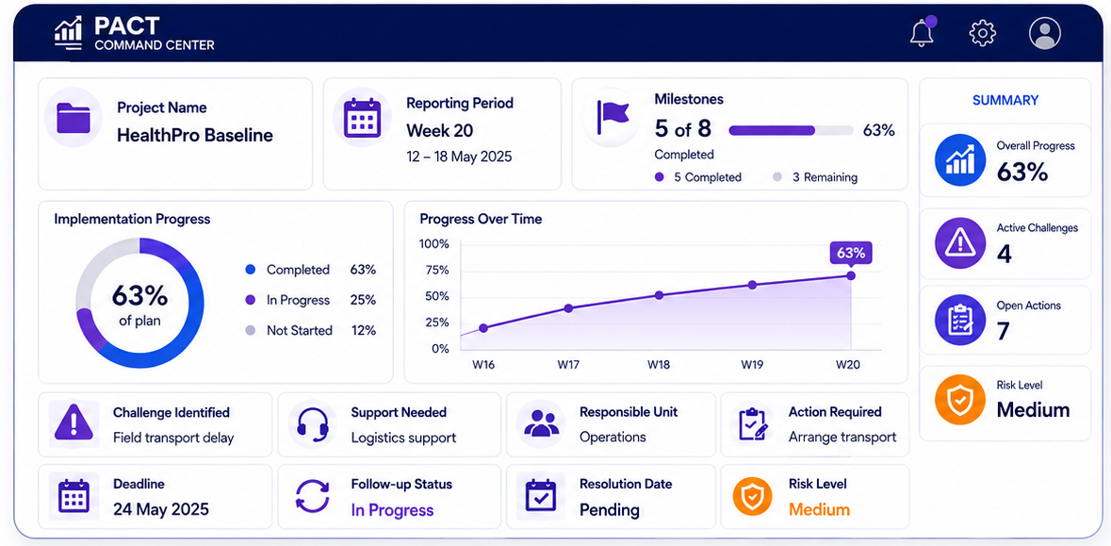
Flow:
Project Director completes update tool → Validated data feeds into project dashboard → Dashboard appears in PACT Command Center → Implementation Department reviews status → Relevant units are engaged → Actions are followed up until resolved.

